Baby Corey_CMF050M__FCS
Coriolis Flowmeter Calculation Summary |  |  |  |  |  | Quote/Rev No: |  |  |  | -/-
Date: |  |  |  | ‭2023-03-30‬
Company: |  |  |  | -
Project Name: |  |  |  | Fall 2022 Campaign
Service: |  |  |  | -
Sensor Model Name : |  |  |  | CMF050M
Sensor Model #: |  |  |  | -
Sizing Name: |  |  |  | Mama Corey
Transmitter Model Name : |  |  |  | -
Transmitter Model #: |  |  |  | -
Transmitter Tag(s): |  |  |  | -
Wetted Material: |  |  |  | 316L
Fluid: |  |  |  | GULF COAST NATURAL GAS
Fluid State: |  |  |  | Gas
K(Flow Consistency Index) |  |  |  | -
n(Flow Behavior) |  |  |  | -
Mass Flow Accuracy (+/- % of Rate) |  |  |  | 00.2500
Pressure Drop at Operating Flow |  |  |  | 0.8842 | psig
Velocity at Operating Flow |  |  |  | 27.6910 | m/sec
 |  |  |  | Min | Operating* |  |  | Max |  |  | Design |  | Units
Flow Rate: |  |  |  | 20.0000 | 100.0000 |  |  | 400.0000 |  |  | - |  | kg/hr
Pressure: |  |  |  | - | 150.0000 |  |  | - |  |  | - |  | psig
Process Fluid Temperature: |  |  |  | - | 50.0000 |  |  | - |  |  | - |  | F
Ambient Temperature: |  |  |  | - | 68.0000 |  |  | - |  |  | - |  | F
Density: |  |  |  | - | 0.5192 |  |  | - |  |  | 0.0000 |  | lb/ft3
Viscosity: |  |  |  | - | 0.0103 |  |  | - |  |  | - |  | cP
Gas Only | Base Reference Temperature: |  | F | 60.0000
Gas Only | Base Reference Pressure: |  | psia | 14.6960
Gas Only | Base Reference Density: |  | lb/ft3 | 0.0440
Process Connection: |  |  |  | -
Process Connection Pressure Rating: |  |  |  | -
@Temperature: |  |  |  | 50.0000 F
Flow Rate | kg/hr | Mass Flow Accuracy (+/- % of Rate) |  | Pressure Drop* | psig |  | Velocity at Operating Flow |  | m/sec |  |  | Re
400.0000 |  | 00.2500 |  | 12.3904 |  |  | 110.7640 |  |  |  |  | 786112.8580
362.0000 |  | 00.2500 |  | 10.1955 |  |  | 100.2414 |  |  |  |  | 711432.1365
324.0000 |  | 00.2500 |  | 8.2145 |  |  | 89.7188 |  |  |  |  | 636751.4149
286.0000 |  | 00.2500 |  | 6.4477 |  |  | 79.1963 |  |  |  |  | 562070.6934
248.0000 |  | 00.2500 |  | 4.8954 |  |  | 68.6737 |  |  |  |  | 487389.9719
210.0000 |  | 00.2500 |  | 3.5576 |  |  | 58.1511 |  |  |  |  | 412709.2504
172.0000 |  | 00.2500 |  | 2.4337 |  |  | 47.6285 |  |  |  |  | 338028.5289
134.0000 |  | 00.2500 |  | 1.5220 |  |  | 37.1059 |  |  |  |  | 263347.8074
100.0000 |  | 00.2500 |  | 0.8842 |  |  | 27.6910 |  |  |  |  | 196528.2145
58.0000 |  | 00.2500 |  | 0.3260 |  |  | 16.0608 |  |  |  |  | 113986.3644
20.0000 |  | 0.3881 |  | 0.0468 |  |  | 5.5382 |  |  |  |  | 39305.6429
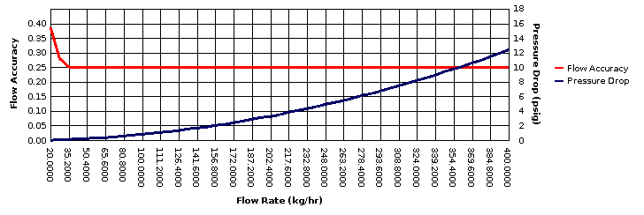
* All pressure drop and velocity results are based on the process conditions (except flow rate) that are entered in the Operating column.

